## Part 3: Implementation of the Case Studies

Please describe how each of the clinical case studies was implemented.

For each of the case studies, please use the format outlined below when reporting the implementation.

### Input (1 page):

* Show the encoded CIGs required to solve the case in your approach formalism

Chronic Kidney Disease PROforma CIG modeling:

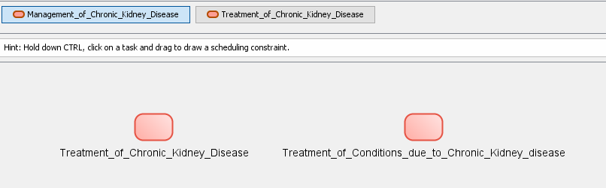

(a)

Addresses metaproperty: Verb: manage, Noun phrase object: Chronic Renal Insufficiency N0000171643 NDF-RT

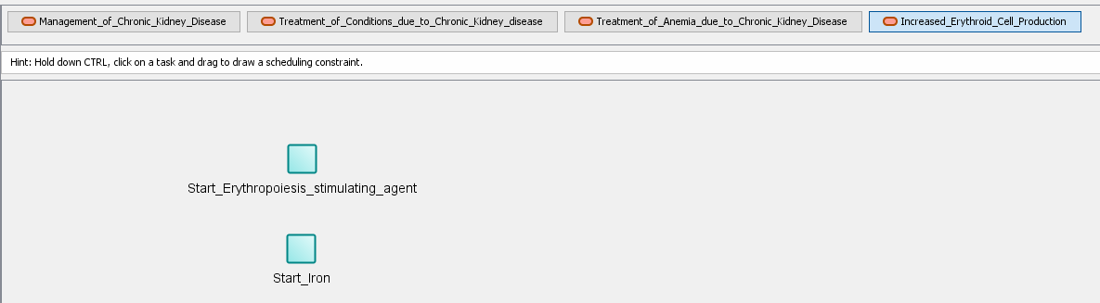

(b)

Addresses metaproperty: Verb: achieve, Noun phrase object:

Type: PE, Modifier: Increased, Clinical attribute: Erythroid Cell Production

Name: Increased Erythroid Cell Production, Code: N0000009319, Vocabulary: NDF-RT

Figure 2-1. Chronic Kidney Disease PROforma CIG hierarchy tree. (a) shows the high-level plan of Management of Chronic Kidney Disease and its metaproperties. (b) shows the plan hierarchy as well as the physiological effect plan “Increased Erythroid Cell Production” metaproperties.

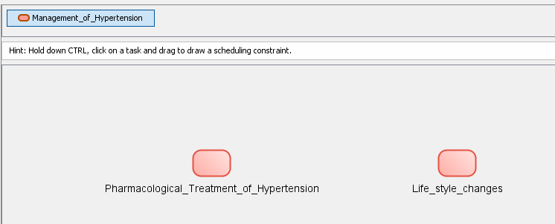

(a)

Addresses metaproperty: Verb: manage, Noun phrase object: Hypertension N0000001616NDF-RT

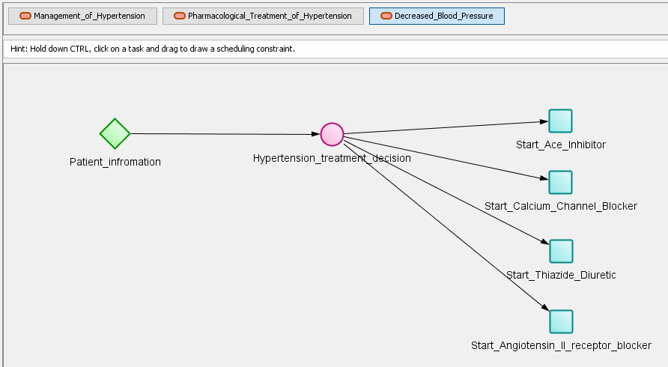

(b)

Addresses metaproperty: Verb: achieve, Noun phrase object:

Type: PE, Modifier: Decreased, Clinical attribute: Blood Pressure

Name: Decreased Blood Pressure, Code: N0000178477, Vocabulary: NDF-RT

Figure 2-2. Hypertension PROforma CIG hierarchy tree. (a) shows the high-level plan of Management of Hypertension and its metaproperties. (b) shows the plan hierarchy as well as the Physiological Effect plan “Decrease Blood Pressure” metaproperties.

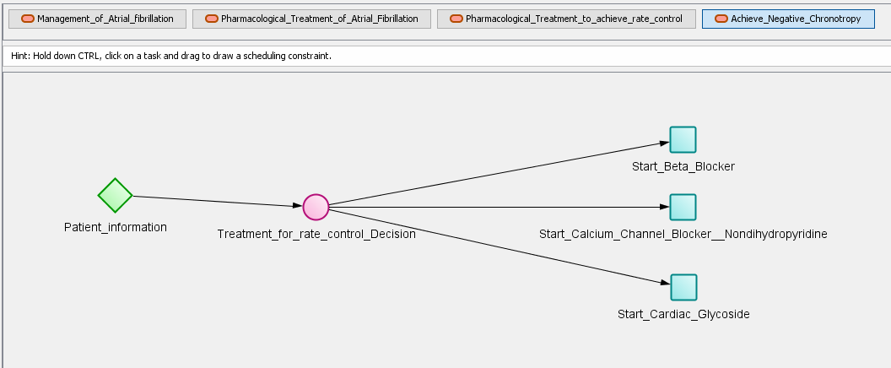

(a)

Addresses metaproperty: Verb: achieve, Noun phrase object:

Type: PE, Modifier: Achieve, Clinical attribute: Negative Chronotropy

Name: Negative Chronotropy, Code: N0000009756, Vocabulary: NDF-RT

(b)

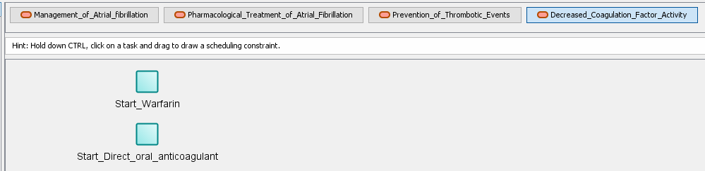

Addresses metaproperty: Verb: achieve, Noun phrase object:

Type: PE, Modifier: Decreased, Clinical attribute: Coagulation Factor Activity

Name: Decreased Coagulation Factor Activity, Code: N0000008556, Vocabulary: NDF-RT

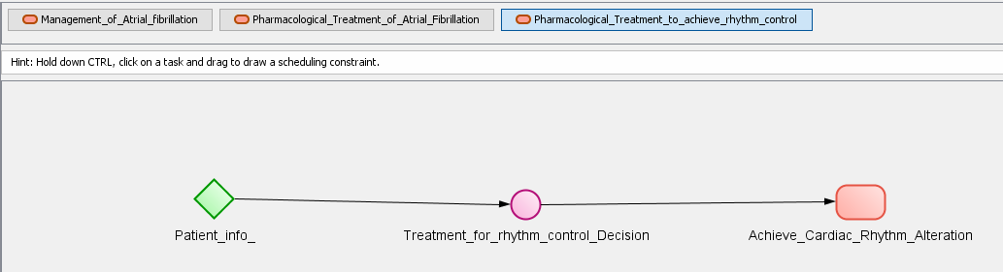

Figure 2-3. Atrial Fibrillation PROforma CIG hierarchy tree. (a) shows the Physiological Effect plan (Negative chronotropy) and its metaproperties. Negative Chronotropy is relevant for all three drugs that can treat Atrial Fibrillation patient and are prescribed to achieve rate control. (b) shows the Physiological Effect plan (Decrease coagulation factor activity) and its metaproperties. This Physiological effect is relevant for all the anticoagulant drugs that are prescribed for patient in order to avoid thrombotic events. (c) Shows the contents of the plan for achieving rhythm control.

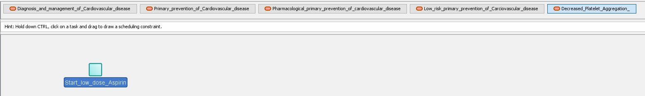

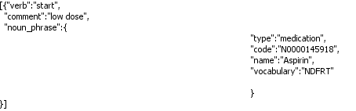

Figure 2-4. Cardiovascular Disease PROforma CIG hierarchy tree. The figure shows the contents of the plan for primary prevention of cardiovascular disease with the sub-plan of the Physiological Effect (Decreased Platelet Aggregation) and the metaproperties for the recommendation to start low dose Aspirin.

The Goal Trees for this case are shown in Figure 2-6.

Example of a FHIR resource (for Case 2): Chronic Kidney Disease (CKD)

{

"resourceType": "**Condition**",

"id": " 1382411",

"clinicalStatus": {

"coding": [ {

"system": "http://terminology.hl7.org/CodeSystem/condition-clinical",

"code": "active"

} ] },

"verificationStatus": {

"coding": [ {

"system": "http://terminology.hl7.org/CodeSystem/condition-ver-status",

"code": "confirmed"

} ]

},

"category": [ {

"coding": [ {

"system": "http://snomed.info/sct",

"code": "282291009",

"display": "Diagnosis of"

} ]

} ],

"code": {

"coding": [ {

"system": "http://hl7.org/fhir/ndfrt",

"code": " N0000171643 ",

"display": "**Chronic Renal Insufficiency** "

} ]

},

"subject": {

"reference": "Patient/135",

"display": "John Curtis"

},

"onsetDateTime": "2018-06-04",}

Figure 2-5 FHIR Observation of CKD (that the patient exhibits)

* If applicable, show how adverse interactions (features A1-A7) were encoded a-priori

Not applicable

* If applicable, show/reference the encoding of additional domain knowledge
  + ESA medications and iron have the physiological effect of “Increased Erythroid Cell Production, N0000009319.
  + All hypertension medications (ACE inhibitors, Calcium Channel Blockers, Thiazide Diuretics, ARBs) have the physiological effect of “Decreased Blood Pressure”, N0000178477.
  + Medications for treatment of Atrial Fibrillation for achieving rate control have the physiological effect of “Negative Chronotropy”, N0000009756.
  + Warfarin and Direct Oral Anticoagulants have the physiological effect of “Decreased Coagulation Factor Activity”, N0000008556.
  + Medications for treatment of Atrial Fibrillation for achieving rhythm control have the physiological effect of “Cardiac Rhythm Alteration”, N0000008330.

### Processing (1 page):

* If applicable, explain how relevant interactions were (automatically) identified (features A1-A7)

**A1 Drug causes ADE**

**A2 Two or more drugs from different CPGs may interact** – In case 2, the Ace Inhibitor and the Calcium Channel Blocker medication recommended by the Hypertension guideline will interact with the Beta Blocker recommended by the Atrial Fibrillation guideline

**A11 Replacing a drug with a safer / non-interacting drug / more effective drug for comorbidity**

May not be relevant to this feature but – the low dose Aspirin should be replaced with either dual therapy or an anticoagulant after the Cardiovascular disease guideline is rerun and primary prevention of CVD turns into secondary prevention due to the Tachycardia and Atrial Fibrillation diagnoses.

**A12 Discard unsafe/interacting drug –**

* If applicable, explain how other relevant features were realized (features C1-C4)

**A15 Patient preferences and/or patient burden –** The Controller produces multiple option-sets with different alternative recommendations for each goal of the patient. In case 2, the Controller will provide options for both the warfarin and a DOAC agent, so that the physician may choose the appropriate medication. According to the case description the patient prefers the DOAC since it does not require frequent INR checks.

**A16 - Optimization of clinical resources – we don't support it**

**C3 Explanation of the mitigation strategy(ies) –** After the different options are created, the Controller creates explanations for each individual goal in each option and a higher-level explanation for each option. The explanations for the individual goals are either retrieved from the guideline or can be auto-generated by the Controller according to pre-defined patterns that take into account the verb and lifecycle Status attribute of the goal (steps 15-27 in Kogan et al. [1] Figure 12 (Pattern F) and in Kogan et al. [1] Table 2).

**C4 Alternative mitigation strategies for a single interaction –** The Controller produces multiple option-sets by applying different mitigation strategies to an interaction. When mitigating the interactions [Start Ace Inhibitor, Start Beta Blocker] and [Start Calcium Channel Blocker, Start Beta Blocker], the Controller will show both options that keep the Ace Inhibitor and Calcium Channel Blocker and options that cancel these medications and allow prescription of the Beta Blocker. (*Note that the best option for the patient is to keep the ACE inhibitor and CCB and in future work the algorithm will omit options that are inferior by all criteria to others).

**C5: Explicit support for decision making among conflicting goals and actions** (i.e., considering priorities and tradeoffs)

See C4. For case 2 the option for Beta Blockers will be shown to the user.

* Explain which parts of the processing are generic and which need to be hardwired for the case[1]

Processing is not hard-wired.

Replacement drugs are represented in the CIGs.

### Output (1 page):

* Show and explain how the result of the processing is represented

The results of the processing have intermediate representation as alternative Goal trees (See Figure 1-7).

**Goal Forest**

**1 Management of Chronic Kidney Disease**

**1.1 Treatment of Conditions due to Chronic Kidney disease**

**1.1.1 Treatment of Anemia due to Chronic Kidney Disease**

**1.1.1.1 Increased Erythroid Cell Production**

**1.1.1.1.1 Start Erythropoiesis stimulating agent**

**2 Management of Hypertension**

**2.1 Pharmacological Treatment of Hypertension**

**2.1.1 Decreased Blood Pressure**

**2.1.1.1 Start Ace Inhibitor**

**2.1.1.2 Start Calcium Channel Blocker**

**2.1.1.3 Start Thiazide Diuretic**

**3 Diagnosis and management of Cardiovascular disease**

**3.1 Primary prevention of Cardiovascular disease**

**3.1.1 Pharmacological primary prevention of Cardiovascular disease**

**3.1.1.1 Low risk primary prevention of Cardiovascular disease**

**3.1.1.1.1 Decreased Platelet Aggregation**

**3.1.1.1.1.1 Start low dose Aspirin**

**4 Management of Atrial fibrillation**

**4.1 Pharmacological Treatment of Atrial Fibrillation**

**4.1.1 Pharmacological Treatment to achieve rate control**

**4.1.1.1 Achieve Negative Chronotropy**

**4.1.1.1.1 start Beta Blocker**

**4.1.2 Pharmacological Treatment to achieve rhythm control**

**4.1.2.1 Achieve Cardiac Rhythm Alteration**

**4.1.2.1.1 start Propafenone**

**4.1.3 Prevention of Thrombotic Events**

**4.1.3.1 Decreased Coagulation Factor Activity**

**4.1.3.1.1 start Apixaban**

Figure 2-6. A schematic representation of the 4 goal trees for the 4 CIGs.

From these, the final output of the goals sets and explanations are derived and presented to users.

The method reports to the user all of the goals for the patient and non-conflicting option sets that meet the goals along with automatically-generated explanations generated from the CIG representation that includes quotes from the CPGs and automatically-generated explanations on the strategy of mitigation and how it has been applied for the case.

Each option-set includes a set of options from the different goal trees of the patient – the ones involved in mitigating the conflicting goals. An option-set is a subtree of the goal tree where the siblings, if any, represent a conjunction of sub-goals. The nodes in the full goal tree, or in the option-pathway are represented as a Goal FHIR object, that start in the root node, with children that are also Goal FHIR objects with children, all the way down to the leaf-node. Note that the property "Proposed action" – contains the future status of the goal as proposed by the Controller during mitigation.

Figure 1-7 provides a schematic representation of Option-set with one pathway for each CIG. Each pathway has 3 nodes from root to leaf. Each line below corresponds to a node in the pathway. The indentation reflects a child-parent relationship.

**Option-set 3 Replace Aspirin with Clopidogrel and stop Omeprazole; proposed**

**1 Management of Chronic Kidney Disease**

**1.1 Treatment of Conditions due to Chronic Kidney disease**

**1.1.1 Treatment of Anemia due to Chronic Kidney Disease**

**1.1.1.1 Increased Erythroid Cell Production**

**1.1.1.1.1 Proposed_action: Keep - Start Erythropoiesis stimulating agent**

**(evidence from guideline)**

**2 Management of Hypertension**

**2.1 Pharmacological Treatment of Hypertension**

**2.1.1 Decreased Blood Pressure**

**2.1.1.1 Proposed_action: Keep - Start Ace Inhibitor (evidence from guideline)**

**2.1.1.2 Proposed_action: Keep - Start Calcium Channel Blocker (evidence from guideline) 2.1.1.3 Proposed_action: Keep - Start Thiazide Diuretic (evidence from guideline)**

**3 Diagnosis and management of Cardiovascular disease**

**3.1 Primary prevention of Cardiovascular disease**

**3.1.1 Pharmacological primary prevention of Cardiovascular disease**

**3.1.1.1 Low risk primary prevention of Cardiovascular disease**

**3.1.1.1.1 Decreased Platelet Aggregation**

**3.1.1.1.1.1 Proposed_action: Cancel - Start low dose Aspirin**

**(auto-generated)**

**3.2 Secondary prevention of Cardiovascular disease**

**3.2.1 Pharmacological secondary prevention of Cardiovascular disease**

**3.2.1.1 Decreased Coagulation Factor Activity**

**3.2.1.1.1 Proposed_action: Reject - start Warfarin (auto-generated)**

**4 Management of Atrial fibrillation**

**4.1 Pharmacological Treatment of Atrial Fibrillation**

**4.1.1 Pharmacological Treatment to achieve rate control**

**4.1.1.1 Achieve Negative Chronotropy**

**4.1.1.1.1 Proposed_action: Reject - start Beta Blocker (auto-generated)**

**4.1.2 Pharmacological Treatment to achieve rhythm control**

**4.1.2.1 Achieve Cardiac Rhythm Alteration**

**4.1.2.1.1 Proposed_action: Accept - start Propafenone (evidence from guideline)**

**4.1.3 Prevention of Thrombotic Events**

**4.1.3.1 Decreased Coagulation Factor Activity**

**4.1.3.1.1 Proposed_action: Accept - start Apixaban (evidence from guideline)**

Figure 2-7. A schematic representation of the json for Option set 3.

Note that as compared to Figure 2-6, there is also a proposed_action part. The proposed action may be to accept, reject, keep, replace, suspend, activate, cancel and complete a goal/action.

After the user selects his preferred option set, the goal tree is updated as is the patient's EHR.

* Show and explain what user interactions were involved in the use case
  + User adding a new problem - Osteoporosis (which triggers the CDS)
  + System providing explanations to the user – See below.
  + User selecting one of the recommended option sets (Option 3 in Figure 2-8). This results in the patient’s EHR being updated

Figure 2-8 shows the options sets for Case2. Figures 2-9 and 2-10 show explanations about one goal from one option set and about an entire Option Set, respectively.

To be completed

Figure 2-8. the option sets for Case 2

There are individual explanations for each recommendation which the user can see when they click on the recommendation for one goal of one of the decision options:

To be completed

Figure 2-9. An explanation for the recommendation to reject Beta Blockers

As well as explanations for the entire option set:

To be completed

Figure 2-10. An explanation for the entire option-set. The explanation is auto-generated.

* Explain any additional considerations.

Not applicable

1. There are two aspects: (**1**) processing algorithm: in a generic approach, only models change across case studies, while a hardwired approach requires tweaking the algorithm for each case study; (**2**) domain knowledge: a mitigation strategy can be generic or hardwired: e.g., deriving which drug should replace another drug can come from a knowledge base or be hard-wired for each case study (e.g., based on guidelines). There can be degrees of generality as well, of course.